DOCUMENTATION

1tommorSemestralProjekt

# Task

**Task**

1. Write a program that will detect the longest subsequence in specified numerical sequence. The program has the output list:
   1. The longest sorted subsequence
   2. The index of the first element longest sorted subsequence.

**Input specifications**

* The program should allow to execute any number of task. Each sequence will be awarded a number of elements, then the individual elements, The program has to end if the specified sequence length is smaller than 1.

**Sample of communication with the user**

|  |
| --- |
| Enter length of the sequence: 7  Enter the sequence: 12 18 17 19 25 34 31  Longest part of the sorted length is 4  Begins with 3. element  Enter length of the sequence: 12  Enter the sequence: 12 18 45 76 48 42 7 10 13 19 21 26  Longest part of the sorted length is 6  Begins with 7. element  Enter length of the sequence: 0 |

# Requirements specification

1. The requirements not specified data type of sequence. Therefore, considering „int “ as standard, which I will use in this program. All error handling will be performed on this data type.

# Proposed solution

* I propose to solve the task by the array. We will check the current and previous member, if the previous member is smaller than actual subsequence is rising, so it´s sorted. If the previous member is larger than the current, it means there is end of sorted subsequence. We must store actual length and start looking if there is any subsequence larger than the previous one.
* Every time we load a new subsequence, it is necessary to store the index of the first member. If there is some subsequence greater than the previous subsequence, it is necessary to overwrite the stored value index of current subsequence.
* At the end of the program will be required to add one into index of first member. Because we do not want index (starting from 0) of first memeber in array, but we wantposition (starting from 1) of first member in array.

# Testing package

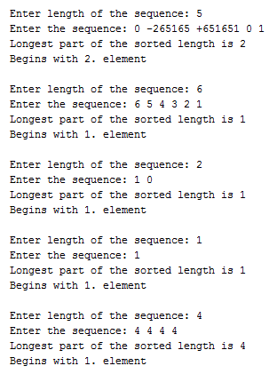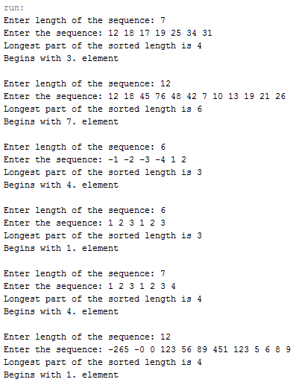

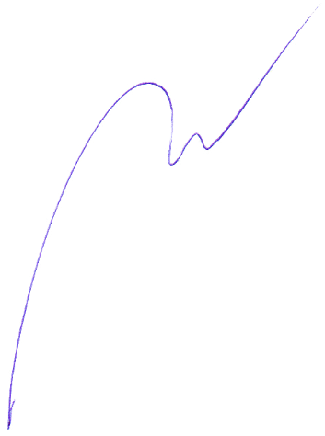

_______________________________  
Tomáš Moravec / M14000260